 | 1st clock | 1st time | Elapsed  time | Time line | 2nd time | 2nd clock
1 | 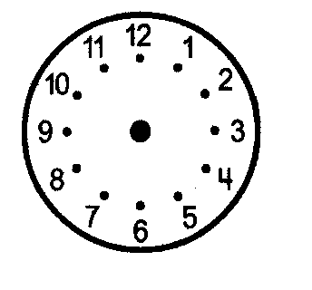
2
3
4
5
 | 1st clock | 1st time | Time change | Time line | 2nd time | 2nd clock
6
7
8
9
10

