A
B
C
D
1) List the factors for each number. Which number has both 3 and 6 for factors?

A. 9
B. 15
C. 24
D. 27
7) What are the common factors of 20 and 28?

A. 1, 2, 4, 7, 10, 14, 28

B. 4

C. 1, 2, 4,

D. Well, they both like soft music, long walks on the beach, and collecting stamps.
ANSWERS

1)    

2)    ☺

3)    

4)    ☺

5)    

6)    ☺

7)      

8)    ☺

2) Which of the following is a prime number?

F. 9
G.  15
H. 7
J. 21
3) Which statement is true about even numbers?

A. There is only 1 prime number that is even.

B. All of them are prime.
C. You can multiply them to make an odd number...

D. They are polka-dotted
4) Which statement best describes this diagram?

F. 8 is a prime number.
G. 8 is a composite number.
H. 6 is a prime number.
J. A feeble attempt by a math teacher with no artistic skill to create a diagram that represents a number (hint: don’t choose this answer).
5) Aaron chose a cup that contained a prime number. Which cup did he choose? (hint: list the factors)

Name______________________________ Date_______________
Prime Numbers and Factors Quiz
6) Which number below is NOT a prime number?

F. 1
G. 2
H. 7
J. r²  cos(f-3xy)/8,800,932 x pink lemonade + Mr. Mendoza x 17 over l(abcdefghijklmnopqrstuvwxyz). And then times zero.

8) Which set of numbers shows ALL of the factors of 24? (hint: don’t get it wrong)

F. 2, 12
G.  2, 12, 3, 8
H. 2, 4, 6, 8, 10
J. 1, 2, 3, 4, 6, 8, 12, 24

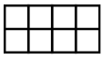
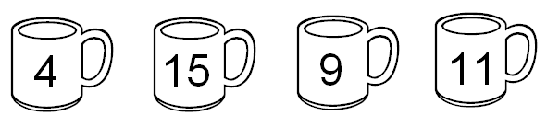
hint
↓

